Family Chicken Pie

8 boneless chicken thighs
2 tbsp oil
3 rashes bacon, chopped
100g mushrooms
1 onion
1 clove garlic, crushed
2 tbsp flour
1 cup liquid chicken stock
¼ tsp mixed herbs
½ cup milk
½ tsp salt
White pepper
200g flaky pastry
1 egg yoke

Optional:
You can also add additional vegetables such as carrots, celery, leeks, peppers, corn etc.
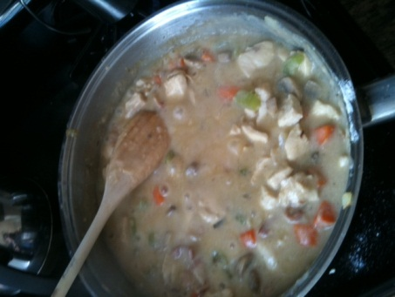
Step 4: Add chicken and milk
- Remove skin from chicken. Cut fresh into 2.5 cm cubes.
- Heat oil in a large saucepan. Add bacon, mushrooms, onion and garlic. Cook until the onion is clear.
- Stir in flour and cook until frothy.
- Gradually add stock and bring to the boil. Add chicken, herbs, milk, any additional vegetables you are adding and salt and pepper to taste. Reduce heat and cook gently for 20 minutes or the chicken juices run clear when tested, stirring occasionally.
- Remove from heat and allow to cool.
- Pour chicken mixture into a 20cm pie dish. Brush edge of dish with water.
- On lightly floured board roll out pastry to a circle large enough to fit top of the pie dish. Carefully place pastry over filling. Press edges firmly to seal, then trim.
Lovely pie enjoyed by all
- Decorate pie with pastry trimmings. Cut steam holes in center of pastry top. Brush pastry with egg yoke.
- Back at 220°C/450°F for 20 minutes until the pastry is golden and well risen.

Serves 6.

